Q2.Perform the following

a.create a report

b.compile and run the report

**OUTPUT:**

**OBJECT NAVIGATOR**

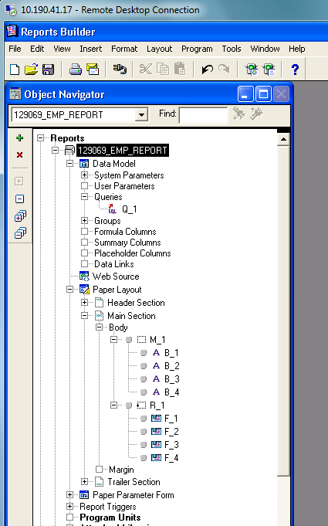

**DATA MODEL**

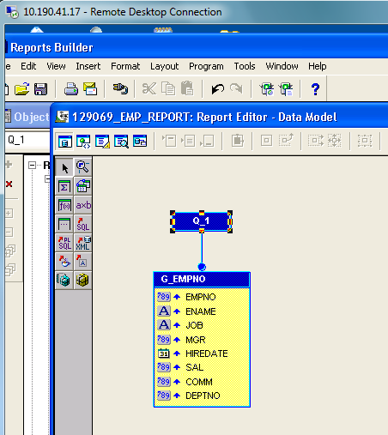

**PAPER LAYOUT**

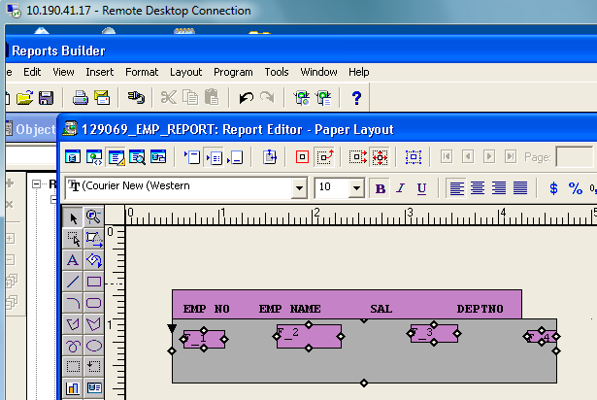

**COMPILING**

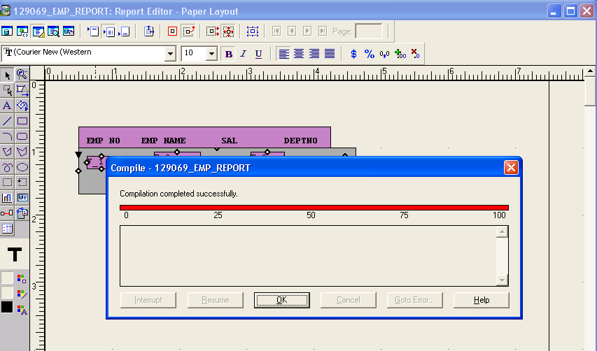

**RUNNIG THE REPORT**

